BUCCANEER 335 SPECIFICATIONS |  |  | 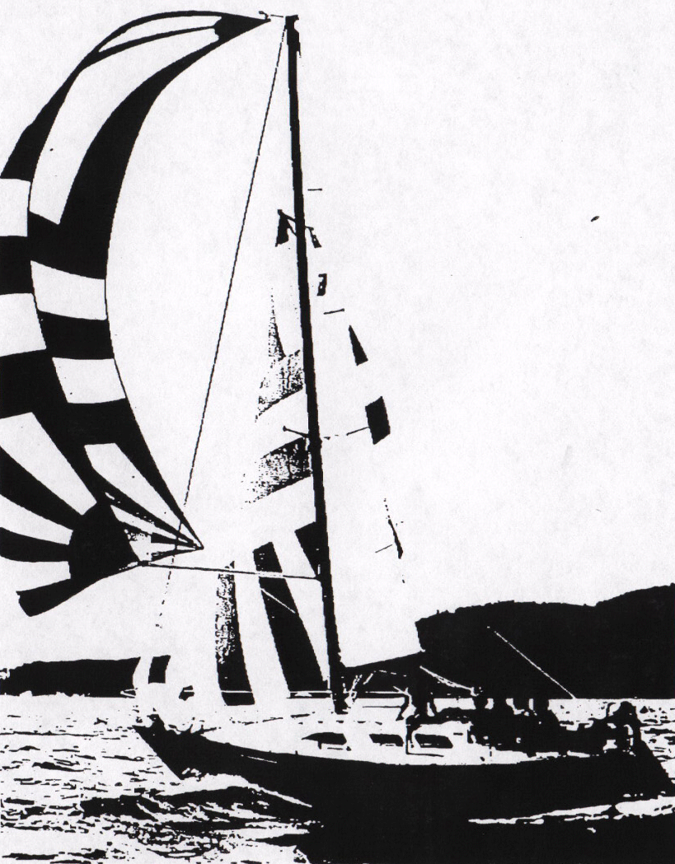
Model  Waterline length  Centerline length  Beam  Weight  Ballast  Maximum headroom  Height waterline  to top of mast  Draft  Sail area  Water capacity  Fuel capacity | B-335  26’ 6”  32’ 10”  12’ 6”  9300 #  4600 #  6’ 0”  46’ 8”  73”  493 sq ft*  20 g  30 g | 8.07 m  10.00 m  3.20 m  4185 kg  2070 kg  1.88 m  14.22 m  1.85 m  45.80 m²  76 l  119 l
* 100% foretriangle

