BUCCANEER 305 SPECIFICATIONS |  |  | 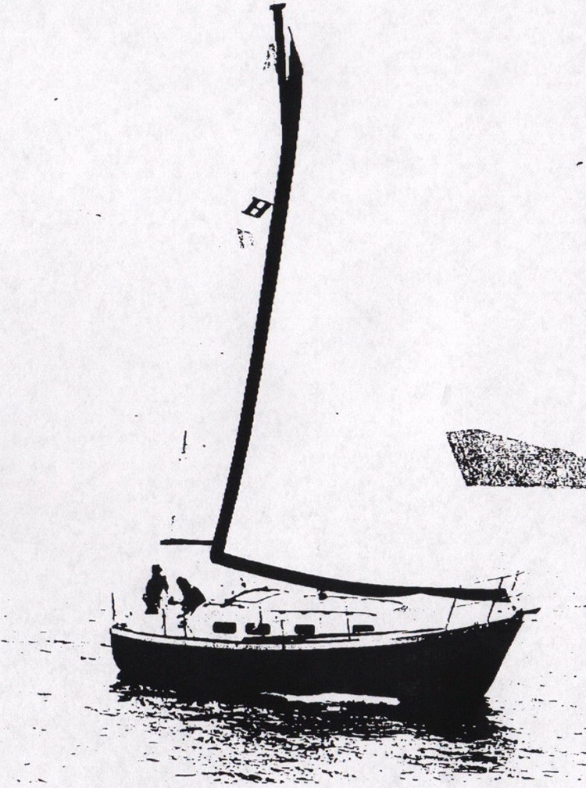
Model  Waterline length  Centerline length  Beam  Weight  Ballast  Maximum headroom  Height waterline  to top of mast  Draft  Sail area  Water capacity  Fuel capacity | B-305  26’ 3”  30’ 0”  12’ 2”  10000 #  3500 #  6’ 2”  44’ 1”  48”  543 sq ft*  36 g  42 g | 8.00 m  9.14 m  3.10 m  4540 kg  1589 kg  1.88 m  13.43 m  1.22 m  50.50 m²  136 l  159 l
130% foretriangle

