BUCCANEER 295 SPECIFICATIONS |  |  | 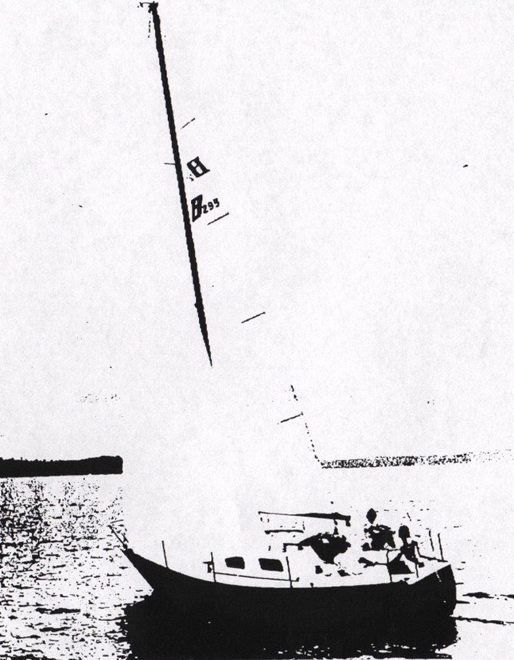
Model  Waterline length  Centerline length  Beam  Weight  Ballast  Maximum headroom  Height waterline  to top of mast  Draft  Sail area  Water capacity  Fuel capacity | B-295  24’ 6”  29’ 3”  10’ 3”  6800 #  2850 #  6’ 0”  41’ 8”  67”  381 sq ft*  12 g  12 g | 7.46 m  8.91 m  3.12 m  3060 kg  1282 kg  1.83 m  12.71 m  1.70 m  35.34 m²  45 l  45 l
100% foretriangle

