BUCCANEER 285 SPECIFICATIONS |  |  | 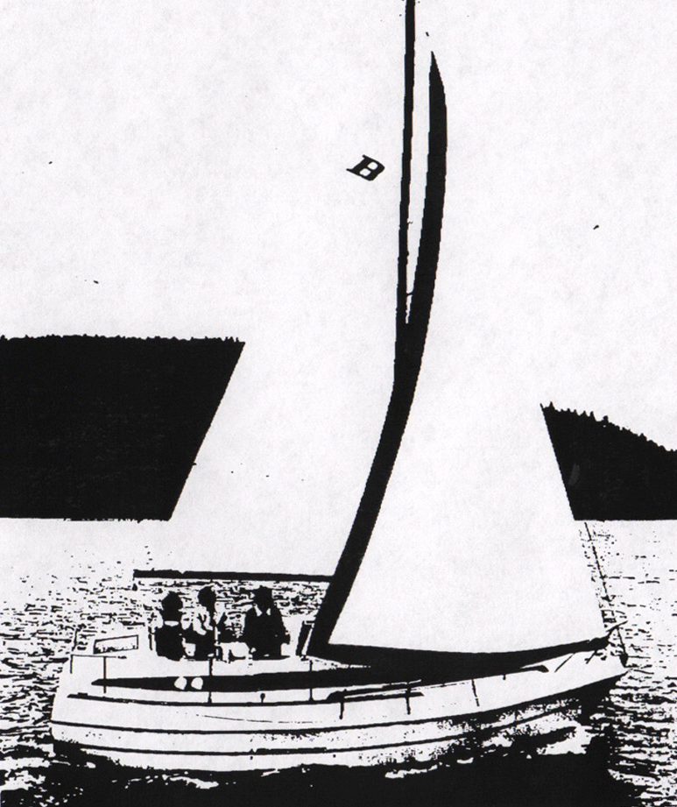
Model  Waterline length  Centerline length  Beam  Weight  Ballast  Maximum headroom  Height waterline  to top of mast  Draft  Sail area  Water capacity  Fuel capacity | B-285  23’ 4”  26’ 8”  96”  6050 #  1650 #  6’ 1”  34’ 8”  27”  380 sq ft*  30 g  24 g | 7.12 m  8.13 m  2.44 m  2747 kg  749 kg  1.86 m  10.56 m  .69 m  35.34 m²  114 l  91 l
150% foretriangle

