BUCCANEER 275 SPECIFICATIONS |  |  | 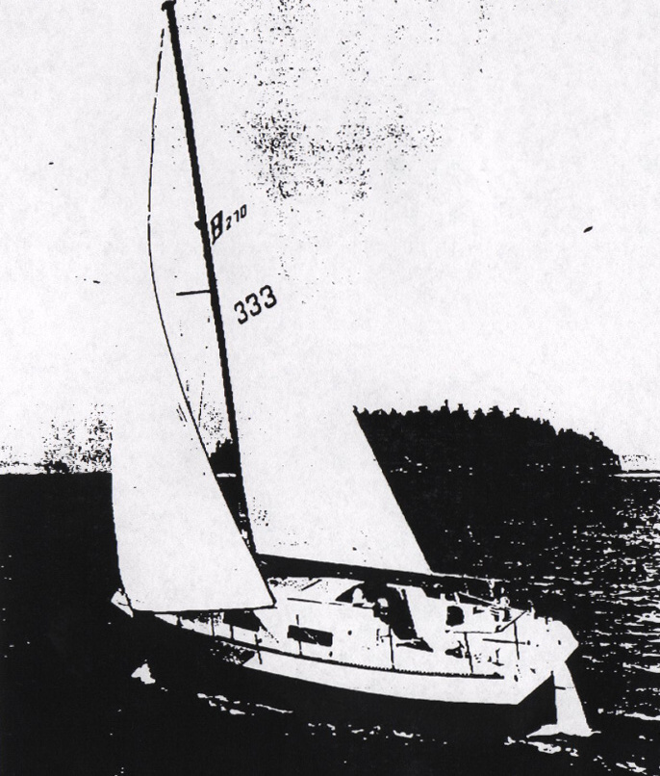
Model  Length overall  Length waterline  Beam  Draft  Cabin headroom  Displacement  Ballast  Sail area  Fuel capacity  Water capacity | B-275  26’8”  23’ 4”  96”  27”  6’ 1”  5850 #  1650 #  306 sq ft*  11 gal  30 gal | 8.13 m  7.12 m  2.44 m  .69 m  1.86 m  2656 kg  749kg  28.33 m²  42 l  114 l
100% foretriangle

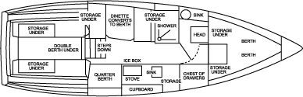

ENGINE UNDER

