BUCCANEER 272 SPECIFICATIONS |  |  | 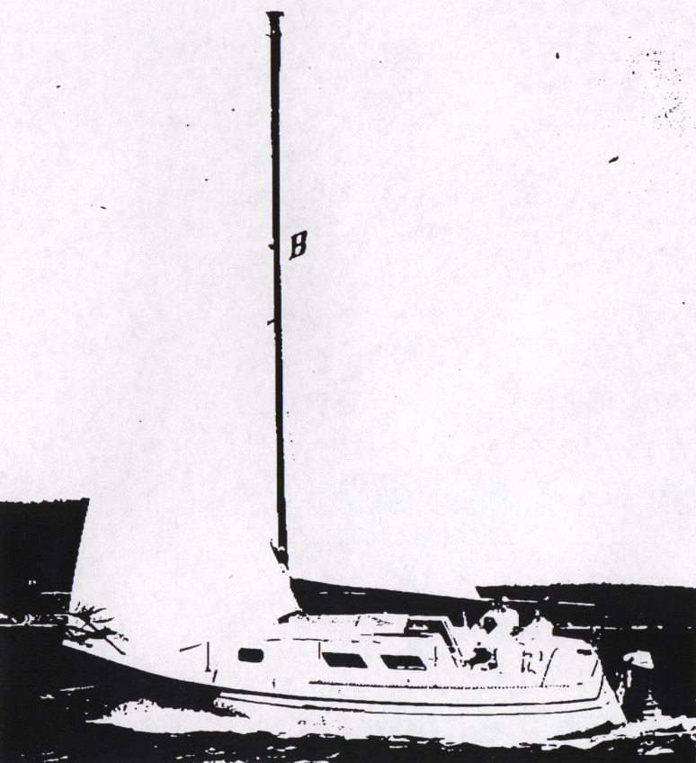
Model  Waterline length  Centerline length  Beam  Weight  Ballast  Maximum headroom  Height waterline  to top of mast  Draft  Sail area  Water capacity | B-272  24’ 6”  27’ 6”  96”  5200 #  1600 #  6’ 1”  34’ 3”  43”  306 sq ft*  20 g | 7.46 m  8.38 m  2.44 m  2340 kg  720 kg  1.86 m  10.43 m  1.22 m  28.33 m²  76 l
100% foretriangle

