BUCCANEER 240 SPECIFICATIONS |  |  | 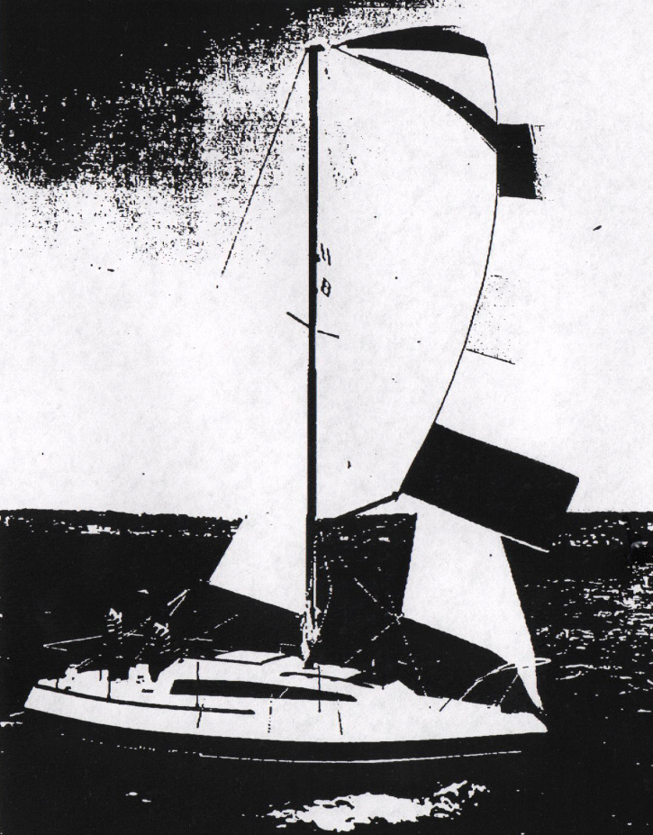
Model  Waterline length  Centerline length  Beam  Weight  Ballast  Maximum headroom  Height waterline  to top of mast  Draft  Sail area  Water capacity | B-240  20’4”  23’ 8”  96”  4000#  1250#  6’ 0”  33’10”  30”  248 sq ft*  20 g | 6.20 m  7.22 m  2.44 m  1816 kg  586 kg  1.83 m  10.31 m  .76 m  23.06 m²  76 l
