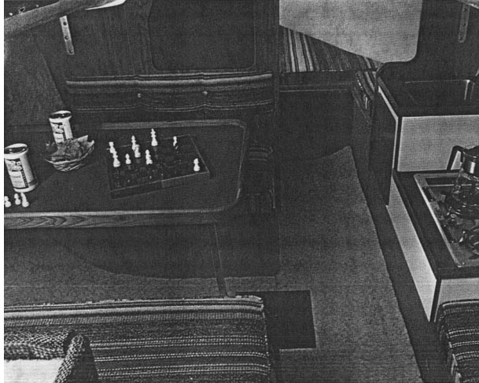 | Here’s a brand new trailerable boat that brings performance cruising into the price range of a lot of families who thought they’d have to settle for less.  Accommodations for four are neatly arranged in a fully enclosed cabin, and depending on your particular needs, the 220 is available in configurations for overnighting or full-flown cruising.  The cockpit and deck are arranged for efficient sail handling, whether for cruising or racing. And with two available keels – standard shoal draft or optional deep fin – you can tailor the 220 to exactly your kind of sailing.  The all-new Buccaneer 220; it’s fast, comfortable, and best of all, affordable.
Cabin is dry, comfortable. Optional galley allows extended cruising.
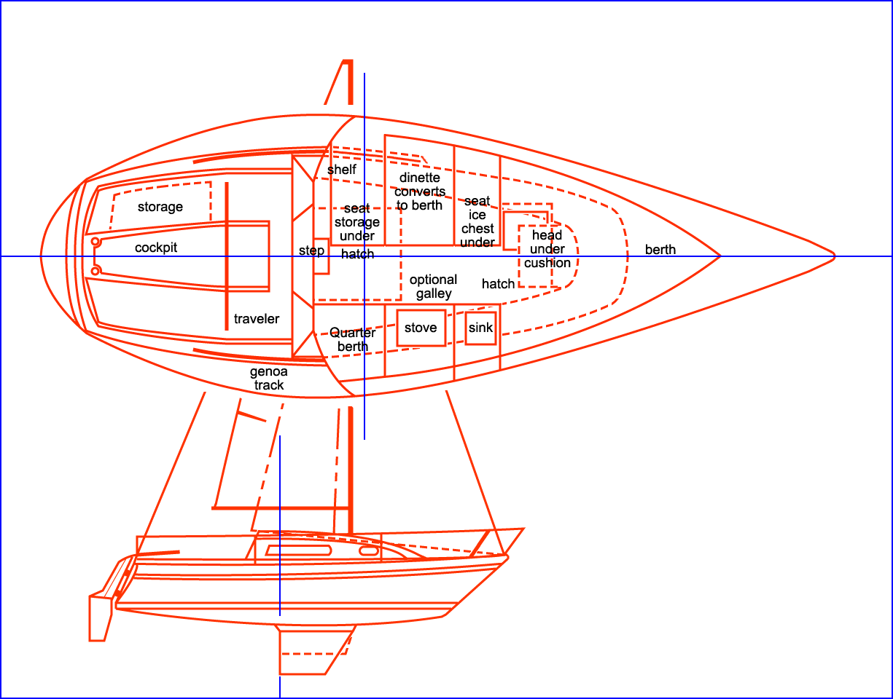 |  | 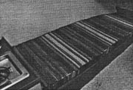
 |  | Full length starboard berth
 |  | 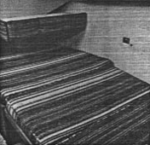 | STANDARD EQUIPMENT:  Cabin: Fabric covered “V” bunk w/ private curtain, quarter berths, dinette with table.  Cockpit: Cockpit drains (2), lockers (2), seats (2), non skid surface, wide coaming seat.  Hardware: cleats (4), genoa tracks (2), foredeck hatch, lifelines, bow pulpits, bow eye, rudder and tiller steering.  Lights: Interior lights, international running lights  Rigging: Black aluminum boom, main and jib halyards, black aluminum mast with complete stainless steel standing rigging, black spreader, traveler, winches (2), hinged mast step.  Safety: Non skid deck surface, self bailing cockpit, fused electrical system.  Sails: Working jib, main sail with jiffy reefing, sail bag.  Storage: Under bunks, cockpit lockers, top loading ice box.  Underwater gear: Fiberglass rudder, removable laminated wood tiller, high lift lead keel.  AVAILABLE ACCESSORIES:  Battery w/box, cockpit dodger, compass, galley cabinet (including 2-burner alcohol stove, ice box, sink, water system) portable head, outboard motor bracket, deep draft keel, manual bilge pump, sail cover.  SPECIFICATIONS:  Length overall 22’0” (6.71m); Waterline length 19’3” (5.87m); Beam 95” (2.41m); Draft 3’0” (.92m); Displacement 2450 lbs (1112kg); Ballast 950 lbs (431kg); Sail area 202 sq. ft. (18.88m²); Height waterline to top of mast 31’3” (9.53m); Cabin 5’3” (1.60m).
The 220 is as fast as it looks |  | Dinette makes into berth
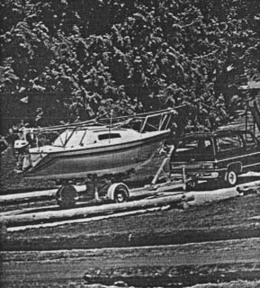 | 