BUCCANEER 220  Buccaneer 220: |  | a quick, fun to sail boat that has room for comfortable overnighting. With the optional galley and portable head, the 220 is perfect for longer trips. The main sail and lapper are standard as well as two sheet winches. The Buccaneer 220 standard configuration is a shoal draft keel with a deeper keel available for racing enthusiasts. |  |  |  |  | 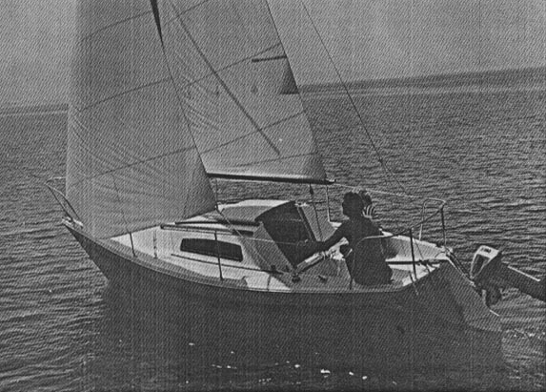
model  length waterline  length overall  beam  draft  displacement  ballast  height waterline to  top of mast  sail area  headroom | 220 BU  19’ 3”  22’ 0”  95”  2’ 2” or 3’ 0”  2450#  950#  31’ 3”  203 sq ft  5’ 3” |  |  | 5.87 m  6.71 m  2.41 m  .66 or .92 m  1112 kg  431 kg  9.53 m  18.88 m  1.60 m
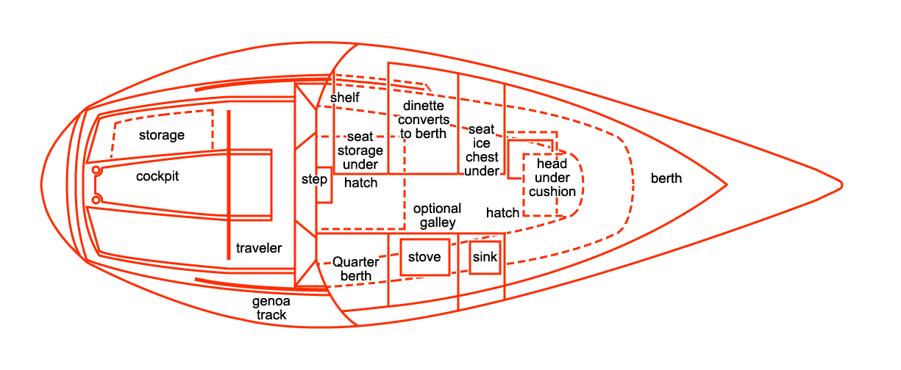 |  |  |  |  |  | RIGGING (cont)  mast step, hinged  stem head fitting, stainless steel  traveler, main sheet  winches (2), sheet  SAFETY  electrical system, fused  non skid deck surfaces  self bailing cockpit  vents to outboard motor fuel  tank locker  COMPLIES WITH ALL COAST GUARD  REGULATIONS IN EFFECT ON DATE  OF CERTIFICATION  SAILS  main, jiffy reefing  jib  sail bag  UNDERWATER GEAR  rudder, fiberglass, outboard  tiller, laminated wood, removable  keel, lead, high lift  pintles and gudgeons, stainless steel  STORAGE  bunks, under  cockpit lockers (2)  optional galley cabinet |  | COLOR OPTIONS  2 ivory hull and deck with gold  hull graphics and rust fabric  5 yellow hull, ivory deck with  orange hull graphics, rust fabric  6 red hull, ivory deck with red  hull graphics, rust fabric  7 brown hull, ivory deck with  brown hull, rust fabric  8 rust hull, ivory deck with  gold hull graphics, rust fabric  9 blue hull, ivory deck with gold  hull graphics, blue fabric  ALL WITH CUSTOM STRIPING ON  HULL SIDES
STANDARD EQUIPMENT  COCKPIT  drains (2)  lockers (2), one for outboard  motor fuel tank, vented  non skid surfaces  seats (2)  wide coaming seat  CABIN  V bunk, fabric covered, with  privacy curtain  curtain, window  dinette with table  galley cabinet optional  quarter berths  large entry hatch  room for optional portable head |  |  | HARDWARE  bow eye, stainless steel  bow pulpit, stainless steel  cleats (4), black Almag 35  hatch, foredeck  life lines  stern pulpit, stainless steel  LIGHTS  interior lights  navigation lights, inland rule  RIGGING  black, double on boom  boom, black aluminum  chain plates, stainless steel  halyards, main and jib  mast and spreaders, black aluminum  with complete stainless steel  standing rigging

