BUCCANEER 210 SPECIFICATIONS |  |  | 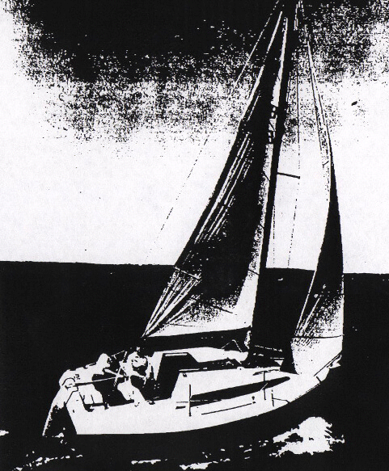
Model  Waterline length  Centerline length  Beam  Weight  Ballast  Maximum headroom  Height waterline  to top of mast  Draft  Sail area  Water capacity | B-210  18’4”  20’10”  96”  3000#  900#  5’8”  29’6”  24”  191 sq ft*  20 g | 5.59 m  6.35 m  2.44 m  1392 kg  409 kg  1.73 m  8.99 m  .61 m  17.67 m²  76 l
