BUCCANEER 180  Buccaneer 180: |  | a fast, easy to sail centerboard daysailer. With the optional bunk cushions, the 180 can be used for overnighting. Colored main and jib sails are standard. Non skid deck surfaces and self bailing cockpit, lockable cuddy cabin and hinged mast step for easy rigging are also standard. The 180 is easily trailered behind small cars. |  |  |  |  | 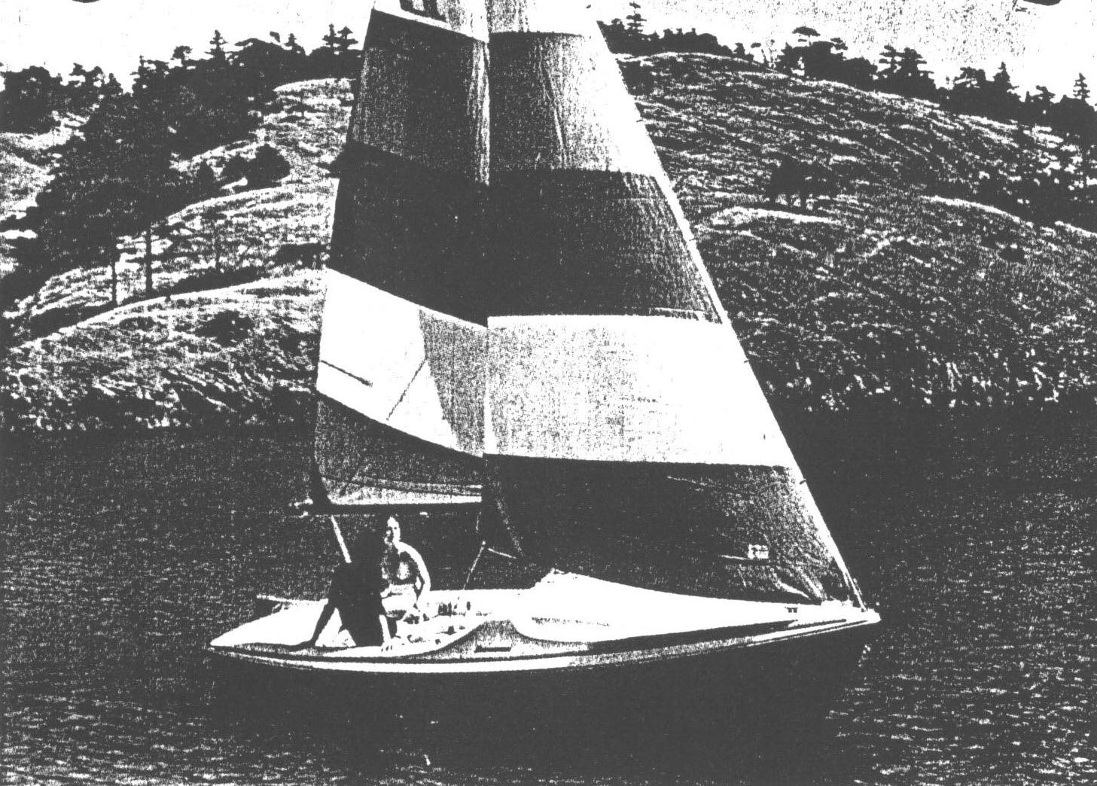
model  length waterline  length centerline  beam  draft  displacement  height waterline to  top of mast  sail area with 100%  foretriangle | 180 BU  15’ 7”  17’ 7”  80”  8”  525#  24’ 2”  134 sq ft |  |  | 4.75 m  5.35 m  2.03 m  .66 m  238 kg  7.36 m  12.46 m²
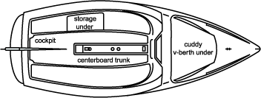 |  |  |  |  |  | SAILS  jib, colored  main, colored  sail bags  UNDERWATER GEAR  rudder, swing up  tiller, laminated wood  weighted swing centerboard  STORAGE  cockpit lockers (2)  cuddy cabin, lockable  COLOR OPTIONS  5 yellow hull, ivory deck  6 red hull, ivory deck  9 blue hull, ivory deck  NOTE: optional bunk cushions are  upholstered in white vinyl |  | OPTIONAL EQUIPMENT  *bunk cushions  outboard motor bracket  overseas packaging  sail cover  shipping cradle  *RECOMMENDED: bunk cushions | CODE  BK  MB  OP  SC  SH | LIST  PRICE  $ 150  100  395  195  250
STANDARD EQUIPMENT  COCKPIT  drains (2)  lockers (2)  non skid surfaces  seats (2)  self bailing  CUDDY CABIN  lockable cabin  area for optional bunk cushions  HARDWARE  bow eye, stainless steel  chocks (2), black Almag 35  mooring cleats (3), black Almag 35 |  |  | RIGGING  block and cam cleats (2), jib  block, fiddle, main sheet  boom, black aluminum  halyards, main and jib  mast and spreader, black aluminum  with complete stainless steel  standing rigging  main sheeting, centrally located  outhaul, main  sheets, main and jib  traveler, main sheet  SAFETY  non skid deck surfaces  polyurethane foam flotation  self bailing cockpit

